Chapter 12, Problem 61.

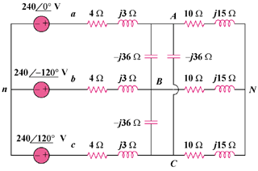
Given the circuit in Fig. 12.67, use PSpice to determine currents I_{aA} and voltage V_{BN}.

Figure 12.67
For Prob. 12.61.

